Hexadecimal (Base 16)
# Source: AI Source: Provided by: [Data Path: Persons Table -> ID Column: 1, Name_En Column: Motasem Essam] -> From: [ChatGPT] on [7/16/2026]
The Hexadecimal Numeral System is a positional numeral system with a base (radix) of 16. It uses sixteen symbols, consisting of the digits 0–9 and the letters A–F, to represent numbers. Each digit's value depends on its position, with each position representing a power of 16.
Hexadecimal is widely used in computer science, programming, digital electronics, memory addressing, networking, and web development because it provides a compact representation of binary numbers.

Definition
# Source: AI Source: Provided by: [Data Path: Persons Table -> ID Column: 1, Name_En Column: Motasem Essam] -> From: [ChatGPT] on [7/16/2026]
The Hexadecimal Numeral System is a positional numeral system in which every digit represents a power of 16.
It is denoted as Base 16.
A hexadecimal numeral consists of the symbols
$$\boxed{0, 1, 2, 3, 4, 5, 6, 7, 8, 9, A, B, C, D, E, F}$$

Base (Radix)
# Source: AI Source: Provided by: [Data Path: Persons Table -> ID Column: 1, Name_En Column: Motasem Essam] -> From: [ChatGPT] on [7/16/2026]
The base of the hexadecimal system is
$$\boxed{16}$$
This means:
- Sixteen unique symbols are used.
- Each position represents a power of 16.

Digits
# Source: AI Source: Provided by: [Data Path: Persons Table -> ID Column: 1, Name_En Column: Motasem Essam] -> From: [ChatGPT] on [7/16/2026]
The hexadecimal system uses the following symbols:
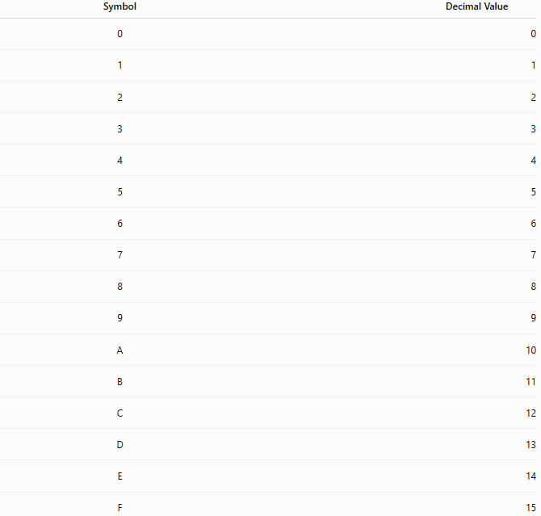
Symbol | Decimal Value
0 | 0
1 | 1
2 | 2
3 | 3
4 | 4
5 | 5
6 | 6
7 | 7
8 | 8
9 | 9
A | 10
B | 11
C | 12
D | 13
E | 14
F | 15

Place Values
# Source: AI Source: Provided by: [Data Path: Persons Table -> ID Column: 1, Name_En Column: Motasem Essam] -> From: [ChatGPT] on [7/16/2026]
From right to left, the place values are
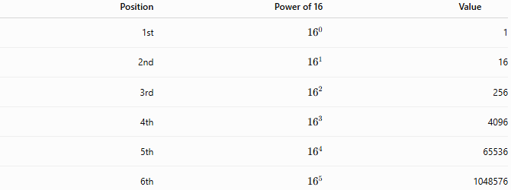
Position | Power of 16 | Value
1st | $${16}^{0}$$ | 1
2nd | $${16}^{1}$$ | 16
3rd | $${16}^{2}$$ | 256
4th | $${16}^{3}$$ | 4096
5th | $${16}^{4}$$ | 65536
6th | $${16}^{5}$$ | 1048576

General Representation
# Source: AI Source: Provided by: [Data Path: Persons Table -> ID Column: 1, Name_En Column: Motasem Essam] -> From: [ChatGPT] on [7/16/2026]
A hexadecimal numeral
$${\left(d_{n}d_{n-1}⋯d_{1}d_{0}\right)}_{16}$$
has the value
$$\boxed{\sum_{k=0}^{n}{d_{k}}{16}^{k}}$$
where each digit satisfies
$$0≤d_{k}<16.$$

Examples
# Source: AI Source: Provided by: [Data Path: Persons Table -> ID Column: 1, Name_En Column: Motasem Essam] -> From: [ChatGPT] on [7/16/2026]
Example 1
Hexadecimal number
$$2F_{16}$$
Expanded form
$$2×{16}^{1}+15×{16}^{0} \\ =32+15={47}_{10}$$

Example 2
Hexadecimal number
$$3A7_{16}$$
Expanded form
$$3×{16}^{2}+10×{16}^{1}+7 \\ =3×256+10×16+7 \\ =768+160+7={935}_{10}$$

Hexadecimal Counting
# Source: AI Source: Provided by: [Data Path: Persons Table -> ID Column: 1, Name_En Column: Motasem Essam] -> From: [ChatGPT] on [7/16/2026]
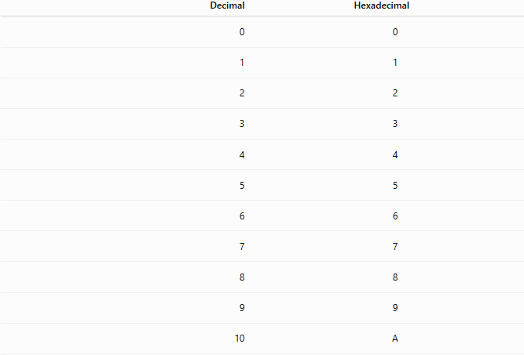
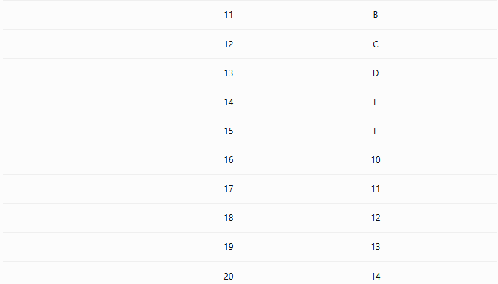
Decimal | Hexadecimal
0 | 0
1 | 1
2 | 2
3 | 3
4 | 4
5 | 5
6 | 6
7 | 7
8 | 8
9 | 9
10 | A
11 | B
12 | C
13 | D
14 | E
15 | F
16 | 10
17 | 11
18 | 12
19 | 13
20 | 14

Hexadecimal Place Value Chart
# Source: AI Source: Provided by: [Data Path: Persons Table -> ID Column: 1, Name_En Column: Motasem Essam] -> From: [ChatGPT] on [7/16/2026]
$${16}^{5}$$ | $${16}^{4}$$ | $${16}^{3}$$ | $${16}^{2}$$ | $${16}^{1}$$ | $${16}^{0}$$
1048576 | 65536 | 4096 | 256 | 16 | 1
Example:
$$5C3_{16} \\ =5(256)+12(16)+3 \\ =1280+192+3={1475}_{10}$$

Hexadecimal Fractions
# Source: AI Source: Provided by: [Data Path: Persons Table -> ID Column: 1, Name_En Column: Motasem Essam] -> From: [ChatGPT] on [7/16/2026]
Digits to the right of the hexadecimal point represent negative powers of 16.
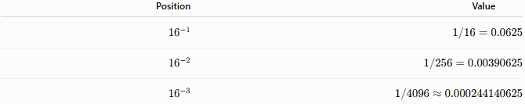
Position | Value
$${16}^{-1}$$ | $$1/16=0.0625$$
$${16}^{-2}$$ | $$1/256=0.00390625$$
$${16}^{-3}$$ | $$1/4096≈0.000244140625$$
Example:
$$A{.8}_{16} \\ =10+\frac{8}{16} \\ ={10.5}_{10}$$

Relationship with Binary
# Source: AI Source: Provided by: [Data Path: Persons Table -> ID Column: 1, Name_En Column: Motasem Essam] -> From: [ChatGPT] on [7/16/2026]
One hexadecimal digit corresponds exactly to four binary digits (bits).
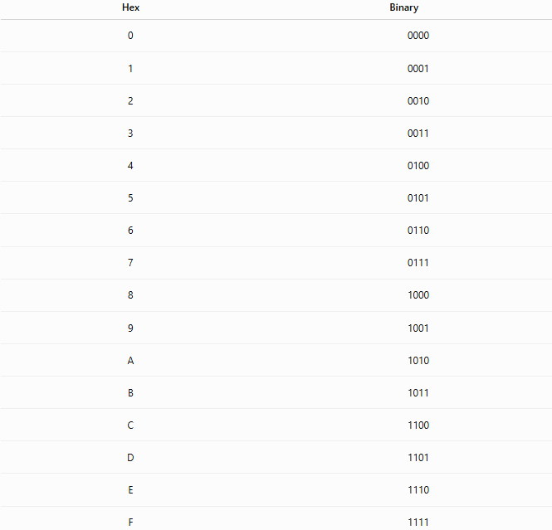
Hex | Binary
0 | 0000
1 | 0001
2 | 0010
3 | 0011
4 | 0100
5 | 0101
6 | 0110
7 | 0111
8 | 1000
9 | 1001
A | 1010
B | 1011
C | 1100
D | 1101
E | 1110
F | 1111
Example:
$$2F_{16}$$
becomes
$$0010 {1111}_{2}$$

Characteristics
# Source: AI Source: Provided by: [Data Path: Persons Table -> ID Column: 1, Name_En Column: Motasem Essam] -> From: [ChatGPT] on [7/16/2026]
The hexadecimal numeral system:
- Is a positional numeral system.
- Uses Base 16.
- Uses sixteen symbols (0–9 and A–F).
- Uses powers of 16 for place values.
- Provides a compact representation of binary numbers.

Arithmetic Operations
# Source: AI Source: Provided by: [Data Path: Persons Table -> ID Column: 1, Name_En Column: Motasem Essam] -> From: [ChatGPT] on [7/16/2026]
Standard arithmetic operations apply in base 16.
Addition
$$A_{16}+5_{16}=F_{16}$$

$$F_{16}+1_{16}={10}_{16}$$

Subtraction
$${10}_{16}-1_{16}=F_{16}$$

Multiplication
$$A_{16}×2_{16}={14}_{16}$$
because
$$10×2={20}_{10}={14}_{16}.$$

Division
$${20}_{16}÷2_{16}={10}_{16}$$

Applications
# Source: AI Source: Provided by: [Data Path: Persons Table -> ID Column: 1, Name_En Column: Motasem Essam] -> From: [ChatGPT] on [7/16/2026]
The hexadecimal system is used in:
- Computer Science
- Programming
- Memory addressing
- Machine language
- Digital electronics
- Networking
- Cryptography
- Embedded systems
- Operating systems
- Computer architecture

Real-Life Applications
# Source: AI Source: Provided by: [Data Path: Persons Table -> ID Column: 1, Name_En Column: Motasem Essam] -> From: [ChatGPT] on [7/16/2026]
Hexadecimal is commonly used for:
- Memory addresses (e.g., 0x7FFE1234)
- HTML/CSS color codes (e.g., #FF0000)
- Unicode character values
- MAC addresses
- Debugging tools
- Machine code
- Binary data representation

Advantages
# Source: AI Source: Provided by: [Data Path: Persons Table -> ID Column: 1, Name_En Column: Motasem Essam] -> From: [ChatGPT] on [7/16/2026]
The hexadecimal system:
- Is much more compact than binary.
- Converts easily to and from binary.
- Is easier for humans to read than long binary strings.
- Is widely supported in programming languages and hardware.

Disadvantages
# Source: AI Source: Provided by: [Data Path: Persons Table -> ID Column: 1, Name_En Column: Motasem Essam] -> From: [ChatGPT] on [7/16/2026]
The hexadecimal system:
- Is less intuitive for everyday arithmetic.
- Requires learning the symbols A–F.
- Is primarily useful in technical fields.

Common Mistakes
# Source: AI Source: Provided by: [Data Path: Persons Table -> ID Column: 1, Name_En Column: Motasem Essam] -> From: [ChatGPT] on [7/16/2026]
- Treating A–F as letters instead of digits.
- Forgetting that A = 10 through F = 15.
- Reading hexadecimal numbers as decimal numbers.
- Confusing hexadecimal with octal.

Key Points
# Source: AI Source: Provided by: [Data Path: Persons Table -> ID Column: 1, Name_En Column: Motasem Essam] -> From: [ChatGPT] on [7/16/2026]
- Hexadecimal is a Base 16 positional numeral system.
- It uses the symbols 0–9 and A–F.
- Each position represents a power of 16.
- One hexadecimal digit corresponds to four binary bits.
- It is extensively used in computing and digital electronics.

Hexadecimal vs. Binary
# Source: AI Source: Provided by: [Data Path: Persons Table -> ID Column: 1, Name_En Column: Motasem Essam] -> From: [ChatGPT] on [7/16/2026]
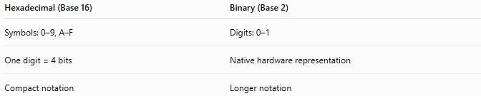
Hexadecimal (Base 16) | Binary (Base 2)
Symbols: 0–9, A–F | Digits: 0–1
One digit = 4 bits | Native hardware representation
Compact notation | Longer notation

Hexadecimal vs. Decimal
# Source: AI Source: Provided by: [Data Path: Persons Table -> ID Column: 1, Name_En Column: Motasem Essam] -> From: [ChatGPT] on [7/16/2026]
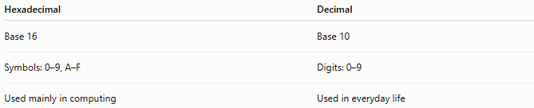
Hexadecimal | Decimal
Base 16 | Base 10
Symbols: 0–9, A–F | Digits: 0–9
Used mainly in computing | Used in everyday life

Hexadecimal vs. Octal
# Source: AI Source: Provided by: [Data Path: Persons Table -> ID Column: 1, Name_En Column: Motasem Essam] -> From: [ChatGPT] on [7/16/2026]
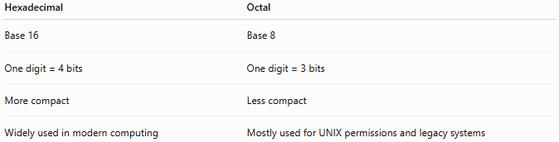
Hexadecimal | Octal
Base 16 | Base 8
One digit = 4 bits | One digit = 3 bits
More compact | Less compact
Widely used in modern computing | Mostly used for UNIX permissions and legacy systems

Conclusion
# Source: AI Source: Provided by: [Data Path: Persons Table -> ID Column: 1, Name_En Column: Motasem Essam] -> From: [ChatGPT] on [7/16/2026]
The Hexadecimal Numeral System is a Base 16 positional numeral system that uses the symbols 0–9 and A–F, with each position representing a power of 16. Because each hexadecimal digit corresponds exactly to four binary bits, hexadecimal provides a compact and efficient way to represent binary data. It is an essential numeral system in computer science, programming, digital electronics, networking, and modern computing.

